Source https://deluxeiceland.is/luxury-tours/essential-iceland-winter/
__________________________________________________________

Iceland Winter Escape: A Self-Drive Journey
__________________________________________________________
★★★★★ 4.7/5 27 reviews

Add to wishlist ♡

__________________________________________________________

6 days / 5 nights | From €2,941 per person

🏕  Image | 🏕  Image | 🏕  Image | 🏕  Image | 🏕  Image | 🏕  Image

__________________________________________________________
About This Tour
Experience the beauty of Iceland during winter on this 6-day self-drive road trip. This tour showcases Iceland’s most iconic attractions, from its majestic waterfalls and geothermal wonders to the Golden Circle, Snæfellsnes Peninsula, and Jökulsárlón Glacier Lagoon. Travel at your own pace, soak in Iceland’s stunning winter landscapes, and discover unique sights, including glaciers, volcanic craters, and black-sand beaches.
__________________________________________________________
What’s Waiting for You
- Duration: 6 days / 5 nights
- Group Size: Self-drive, ideal for families, couples, or solo travelers
- Accommodation: Five nights at Four/Three Star Hotels (Double Rooms with breakfast)
- Languages Available: English
- Private Guided Tour: Fully personalized experience
- Transportation: Luxury 4x4 Rental Vehicle with Wi-Fi, unlimited mileage, and CDW insurance
- Season: Available from 1 October to 30 April
__________________________________________________________

Check Dates & Availability

Select participants: (Age 99 and younger) - 1 +

Choose date:
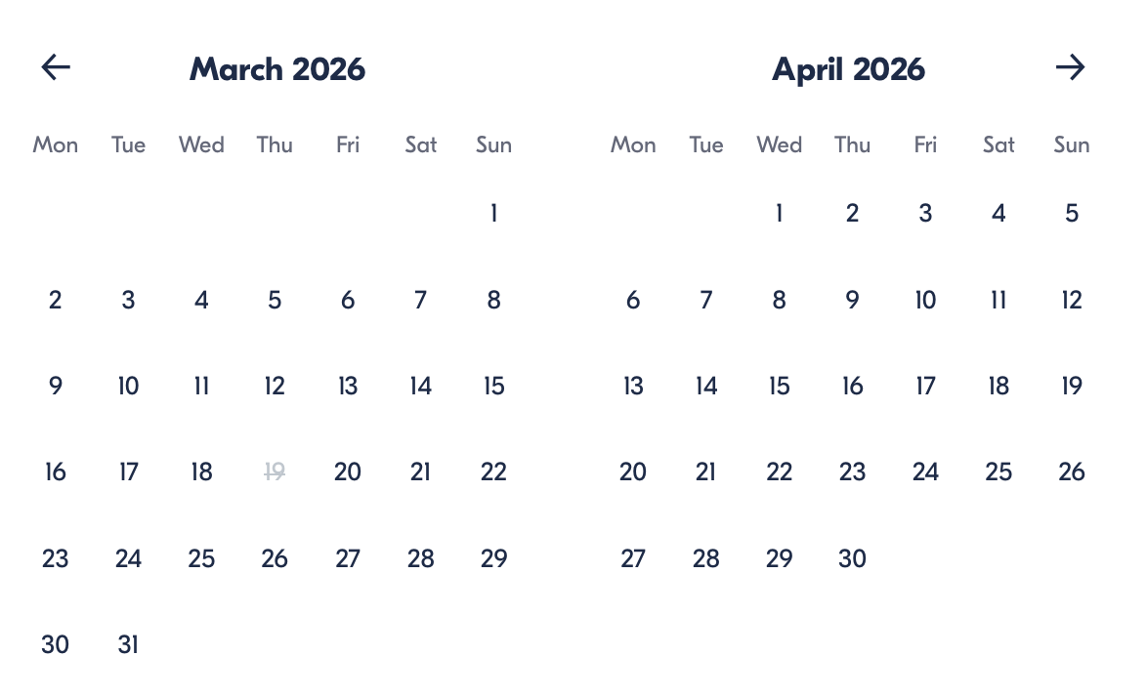

Check Availability

opens:

Participants: 2 March 16, 2026

Iceland Winter Escape: A Self-Drive Journey

- Duration: 6 days
- Offered in: English
- Starts at: 10:30 AM

Cancellation:

- More than two weeks prior to arrival: 40% Credit / 60% Refunded
- Less than two weeks prior to arrival: 50% Credit / 50% Refunded
- Less than 72 hours prior to arrival: No refund and no credit

Price breakdown: 2 Participants x €2,941

Total: €5,882

The total price includes all taxes and fees.

Add to cart Book now

__________________________________________________________
Tour Features
- Self-Drive Experience: Explore Iceland’s stunning winter landscapes at your own pace
- Luxury 4x4 Rental Vehicle: Choose from Mercedes-Benz GLE, Land Rover Defender, or Discovery
- Golden Circle: Visit Þingvellir National Park, Geysir Geothermal Area, and Gullfoss Waterfall
- Snæfellsnes Peninsula: Explore Iceland in miniature with dramatic coastlines and volcanic landscapes
- Jökulsárlón Glacier Lagoon: Marvel at the icebergs in the lagoon and enjoy a zodiac boat tour
- Blue Lagoon: End your journey with a relaxing soak at one of Iceland’s most famous geothermal spas
__________________________________________________________
Detailed Itinerary
- Day 1 – Arrival in Reykjavik
Arrive in Iceland at Keflavik Airport, where your private representative will greet you and assist you in picking up your luxury rental car. Go over your itinerary in detail and then spend the day exploring Reykjavik, the northernmost capital city in the world. Explore museums, enjoy delicious local cuisine, and soak in the city’s vibrant atmosphere.
Accommodation:
Hotel Borg, Reykjavik (Included in price)
__________________________________________________________
- Day 2 – The Golden Circle
Today, drive the famous Golden Circle route, starting with Þingvellir National Park, a UNESCO World Heritage site where you can walk between the North American and Eurasian tectonic plates. Then, visit the Geysir Geothermal Area, home to the famous Strokkur geyser. End the day with a visit to Gullfoss Waterfall, one of Iceland’s most stunning natural landmarks.
Accommodation:
Hotel Rangá, South Iceland (Included in price)
__________________________________________________________
- Day 3 – The South Shore & Glacier Walk
Explore the South Shore, visiting Seljalandsfoss and Skógafoss Waterfalls. Then, enjoy an exciting glacier walk on Sólheimajökull Glacier, where you’ll experience the icy beauty of Iceland’s glaciers up close. Continue your journey to your next hotel.
Accommodation:
Hotel Rangá, South Iceland (Included in price)
__________________________________________________________
- Day 4 – The Glacier Lagoon & Zodiac Boat Ride
Visit Jökulsárlón Glacier Lagoon, where you’ll embark on a zodiac boat tour among the floating icebergs. This is an incredible experience that offers the opportunity to taste 1,000-year-old ice and possibly spot some seals. Afterward, continue to your next hotel.
Accommodation:
Fosshotel Glacier Lagoon, Southeast Iceland (Included in price)
__________________________________________________________
- Day 5 – The Eastfjords & Viking Village
Drive through the Eastfjords, known for their dramatic coastlines, picturesque villages, and scenic fjords. Stop at Vestrahorn mountain and visit the Viking Village, a film set open to the public. Continue on to your next accommodation for the night.
Accommodation:
Fosshotel Eastfjords, East Iceland (Included in price)
__________________________________________________________
- Day 6 – Departure via the Blue Lagoon
On your final day, drive to the Blue Lagoon for some relaxation before your flight. You’ll have premium access to the geothermal spa, where you can unwind and rejuvenate. Afterward, drop off your rental car at Keflavik Airport for your departure.
__________________________________________________________
Included in Price
- Luxury 4x4 Rental Vehicle with Wi-Fi and unlimited mileage
- CDW Insurance and Map of Iceland
- Retreat Spa Entrance to Blue Lagoon
- Private Zodiac Boat Tour and Whale Watching
- Private Glacier Walking Tour
- Five nights at Four/Three Star Hotels (Double Rooms with breakfast)
- Private arrival transfer & meeting with a Deluxe Iceland representative
- All taxes and fees – no hidden charges
__________________________________________________________
Not Included
- Meals (Lunches and dinners are not included)
- International Flights
__________________________________________________________

Cancellation Policy
For 5 or Fewer Participants:
- More than 2 weeks before arrival: 40% Credit / 60% Refund
- Less than 2 weeks before arrival: 50% Credit / 50% Refund
- Less than 72 hours before arrival: No refund or credit
For 6 or More Participants:
- More than 4 weeks before arrival: 40% Credit / 60% Refund
- Less than 4 weeks before arrival: 80% Credit / 20% Refund
- Less than 2 weeks before arrival: No refund or credit
Changes in the number of participants may increase the price per person. We recommend comprehensive travel insurance.
Weather-Related Cancellations:
If activities are canceled due to weather, they will be fully refunded. Itineraries may change based on conditions, with safety as the top priority.
Refund Processing:
Refunds are processed within 15 days after the tour ends.
__________________________________________________________
What Our Clients Are Saying

Overall rating  4.7/5  ★★★★★  Based on 27 reviews | Review summary  Guide 4.5/5  Transportation 4.6/5  Service 4.7/5  Organisation 4.5/5

Filter  - All traveller types  - Couples  - Group of friends  - Families  By star rating  - All star ratings  - 5 stars  - 4 stars  - 3 stars  - 2 stars  - 1 star | Search reviews (e.g., guide)  Sort by:  - Top picks  - Latest reviews  - Best ratings  - Lowest ratings
__________________________________________________________
★★★★★
Anna – Italy
A truly unforgettable experience! The self-drive tour allowed us to explore at our own pace while still seeing all the iconic sites. Highly recommend this adventure!

★★★★★
David – Canada
What an incredible way to discover Iceland! The flexibility and variety of the itinerary made the trip perfect. The glacier hike was amazing, and the whale watching was a highlight!

★★★★☆
Sophie – Spain
Una experiencia increíble! El recorrido por la isla fue espectacular y conducir por los paisajes impresionantes fue una gran experiencia. Hubiera preferido pasar más tiempo en Reykjavik, pero fue una aventura maravillosa.

See more reviews
__________________________________________________________

Meta tags

Page - Iceland Winter Escape: A Self-Drive Journey

Title: Iceland Winter Escape: A Self-Drive Journey | Travellio Global

Description: Experience the stunning beauty of Iceland during winter on a self-drive road trip. Explore iconic landscapes, waterfalls, glaciers, and the unique Icelandic culture at your own pace with a luxury rental vehicle.

H1 - Iceland Winter Escape: A Self-Drive Journey
__________________________________________________________

